# Week 01 Assignment

## Project Creation in Intellij

New Project -> Java Enterprise => Select Version: Jakarta EE, Spec: Persistence(JPA), Impl: EclipseLink

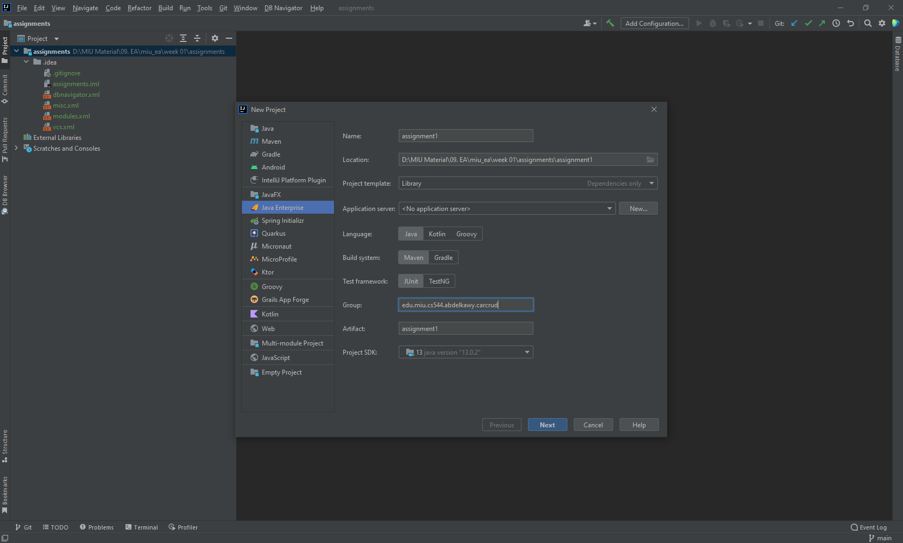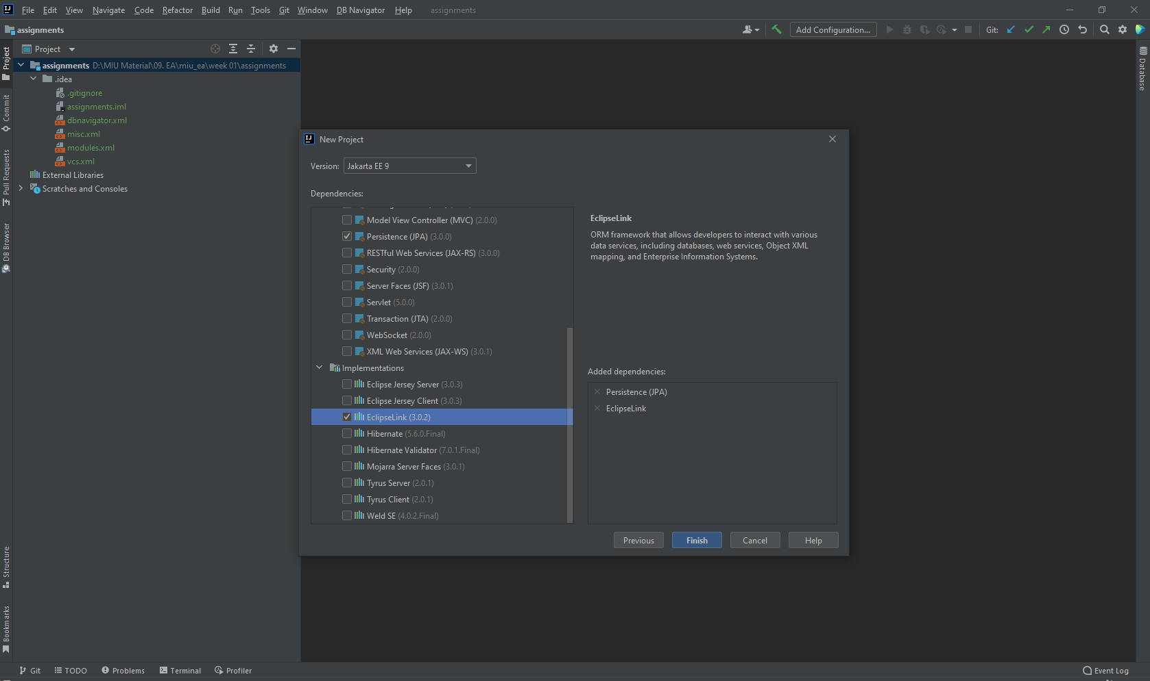

Add Dependency for mysql connector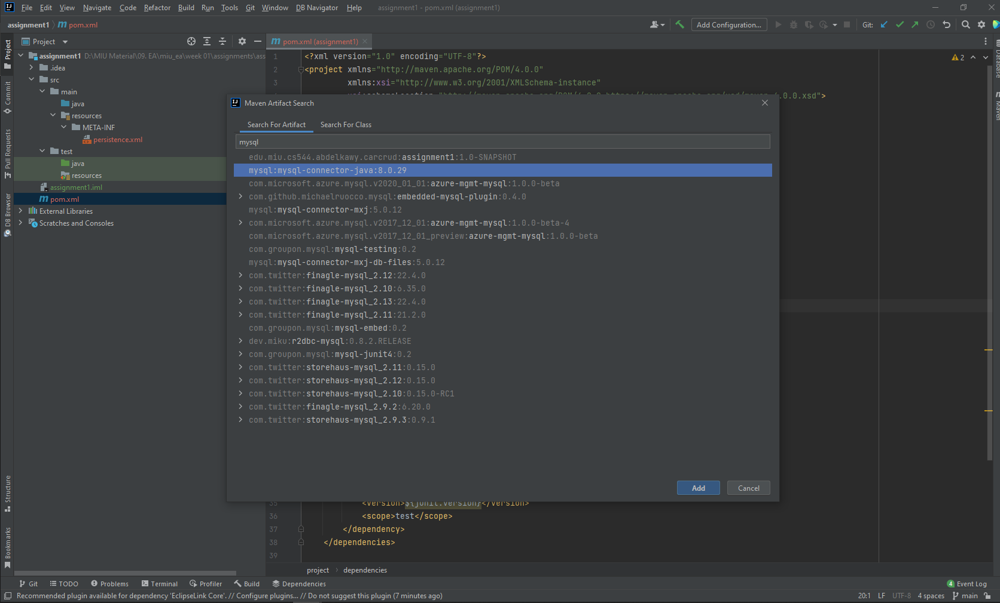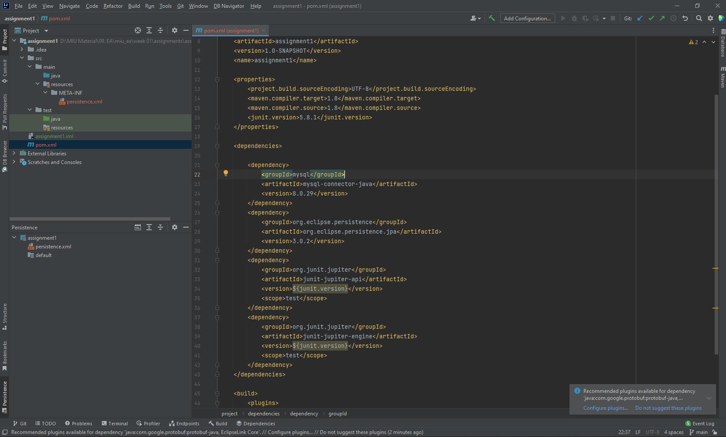

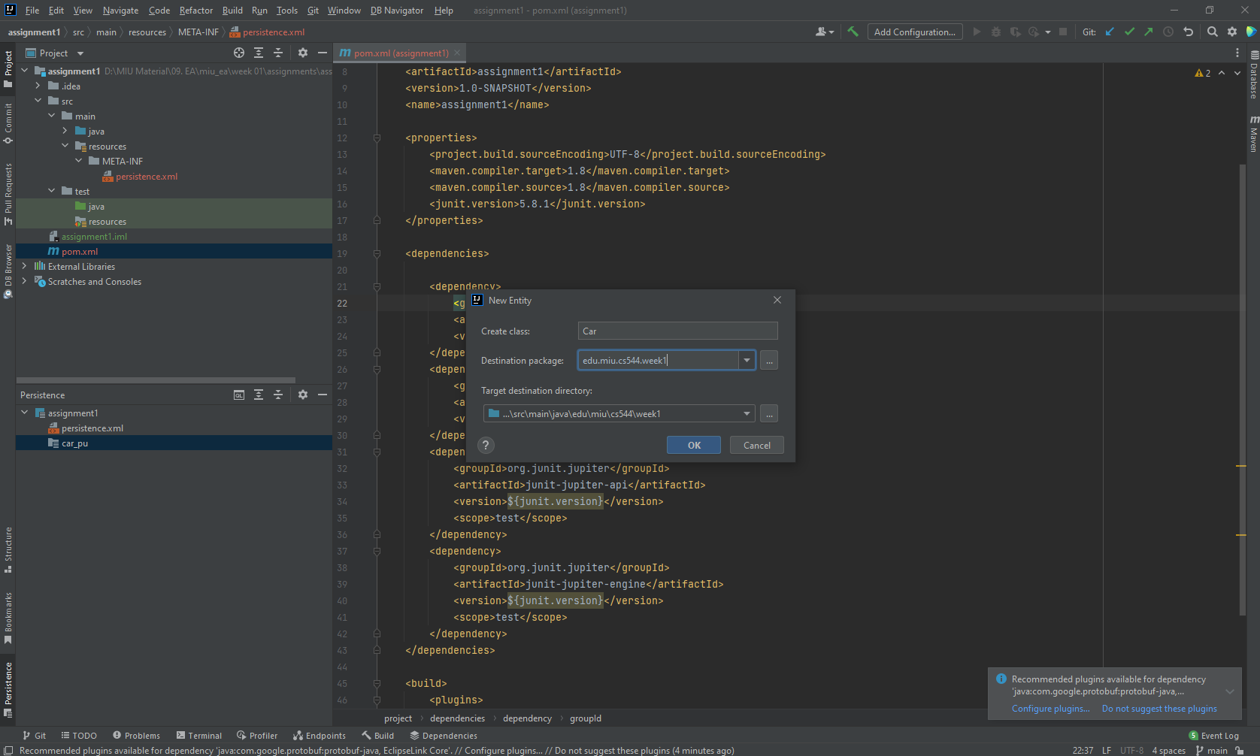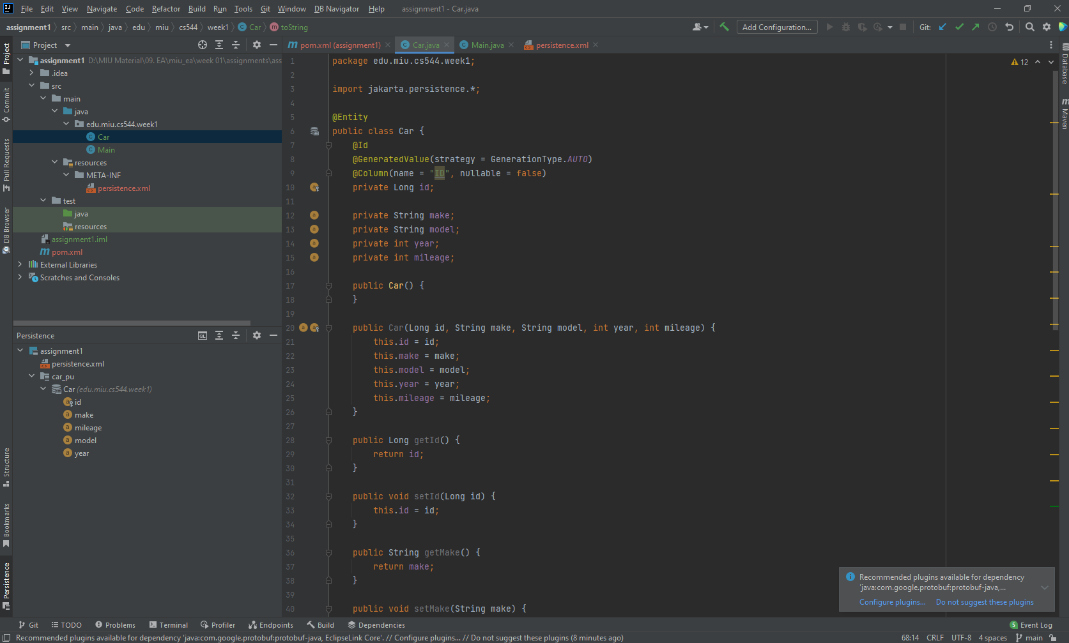

Click shift twice and search: “Persistence” to get the persistence tool window in the bottom-left. Then change the name of the “default” persistence unit to “car_pu”. Then right click and create entity “  
Car” and add fields as required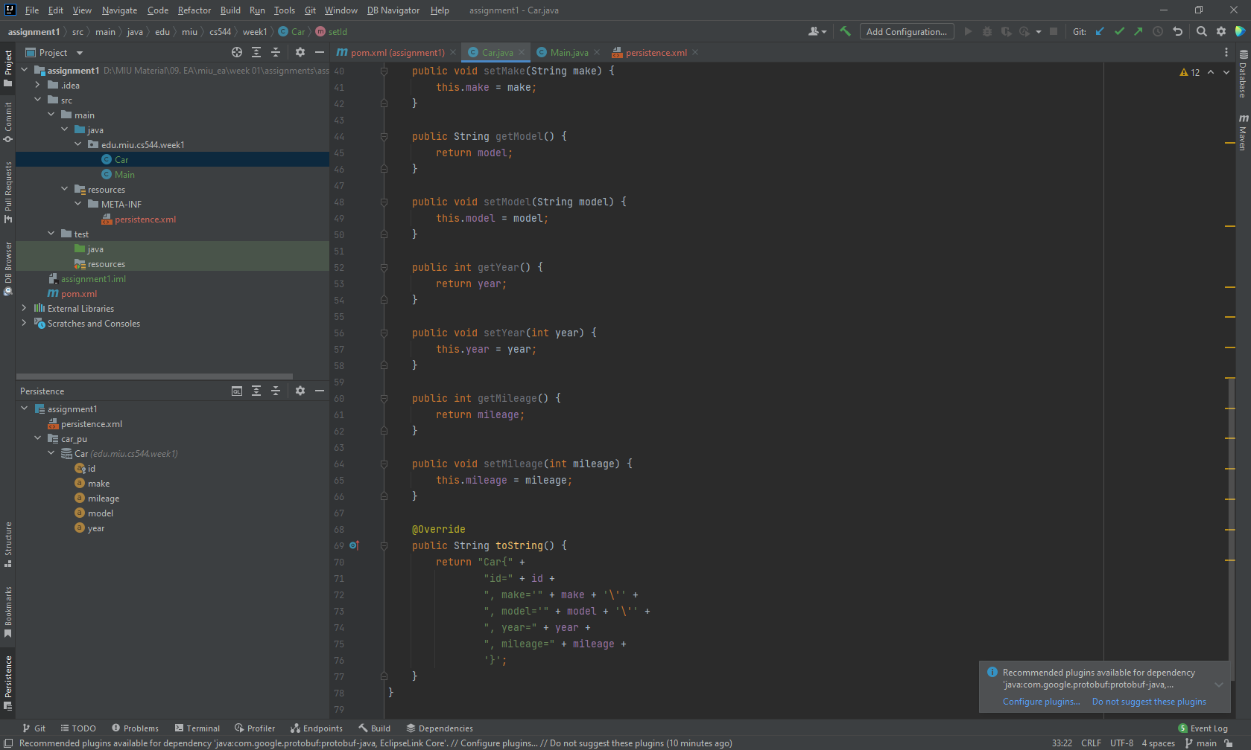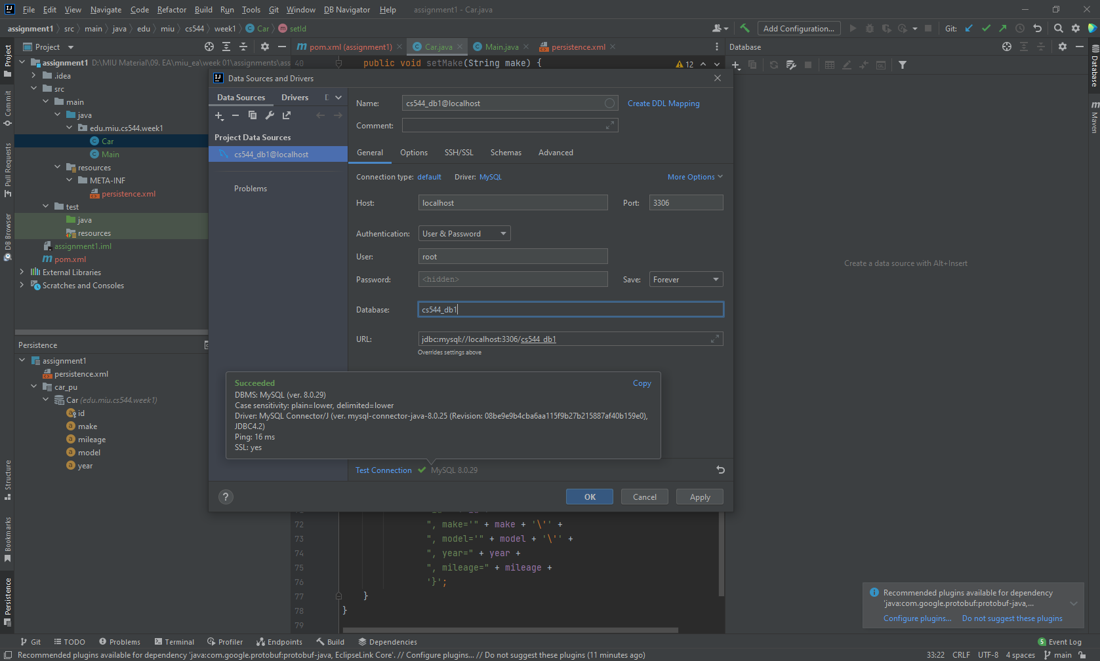View -> Tool Windows -> Database --- add data source and edit parameters as above

Edit persistence.xml and provide properties as below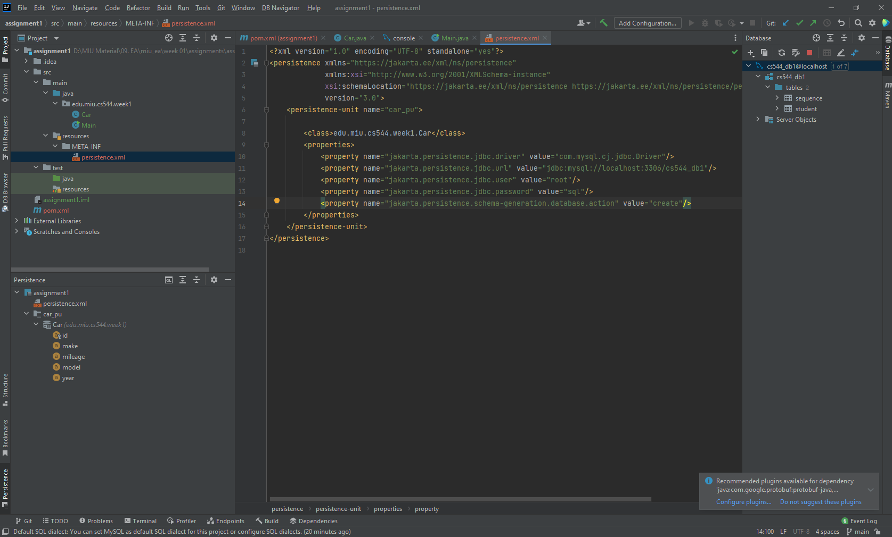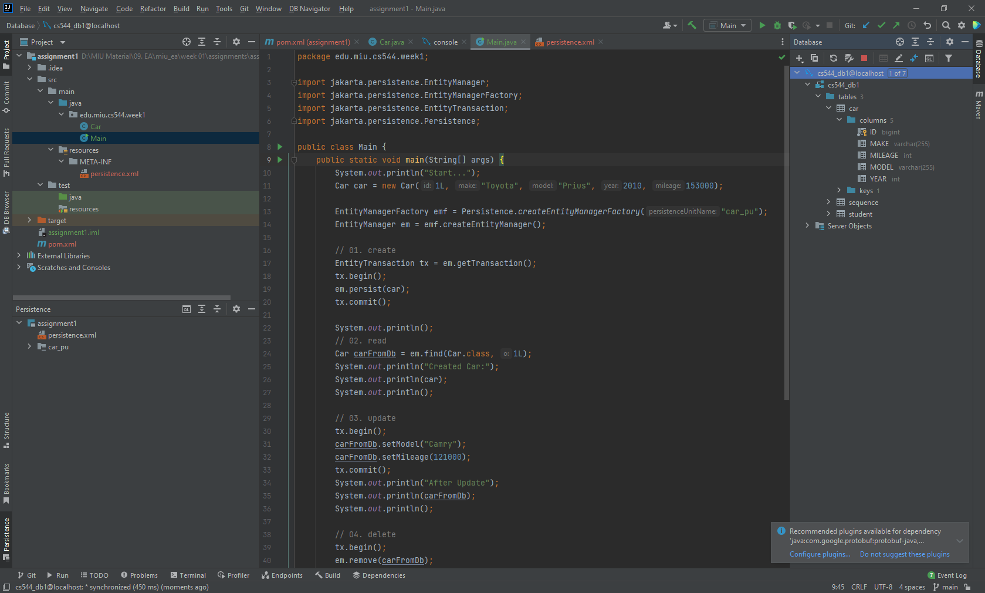The Car Entity after adding needed fields, constructors, accessors and mutators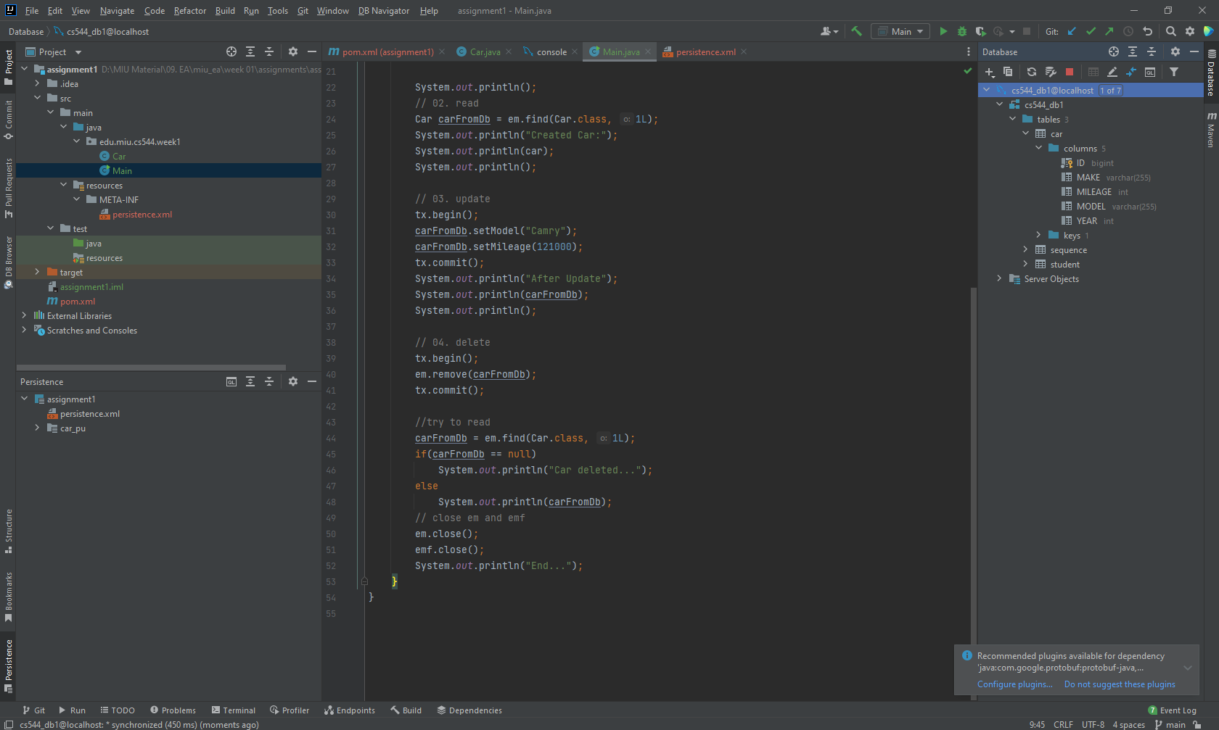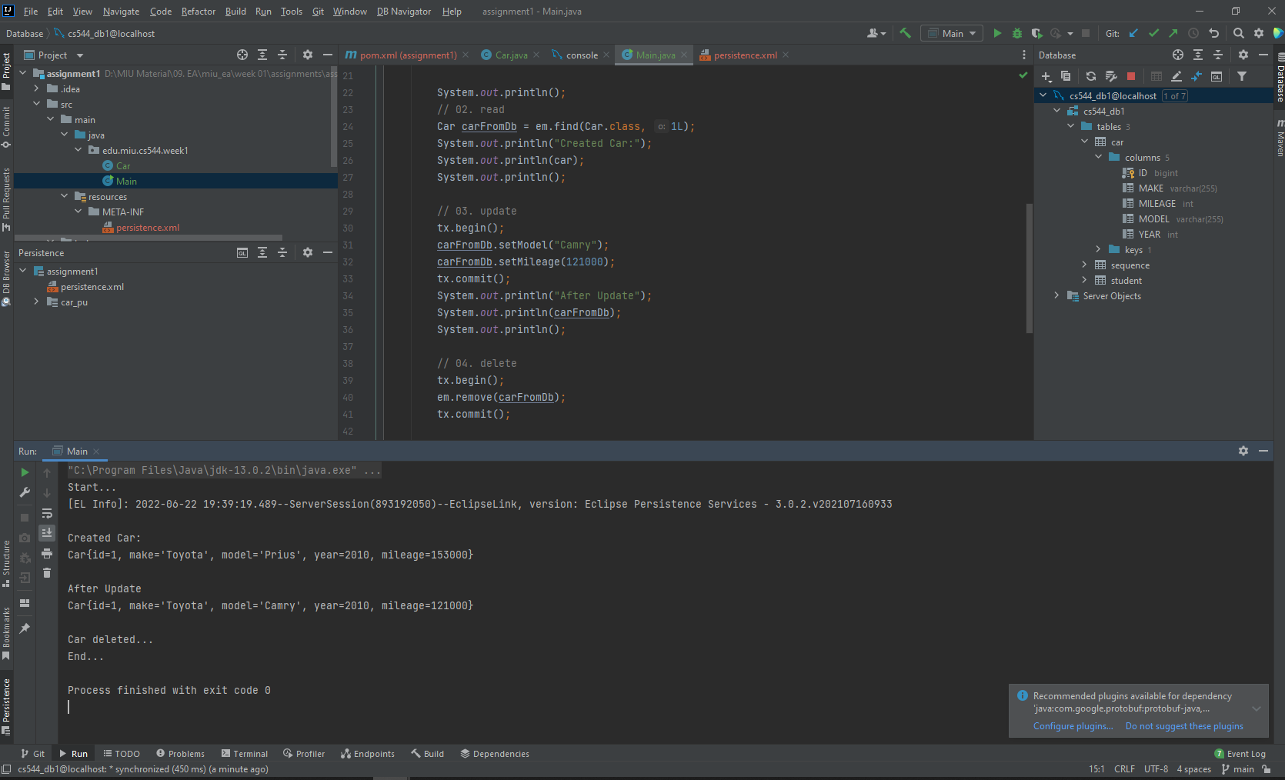The Main method with the CRUD operations and the result after running

References  
01. Lecture 1 - EA course  
02. Creating Simple Jakarta JPA application in Intellij (Similar to lecture but for Intellij)  
[Creating a Simple Jakarta Persistence/JPA Application in IntelliJ IDEA Ultimate - YouTube](https://www.youtube.com/watch?v=jB2uSJX7jnM)